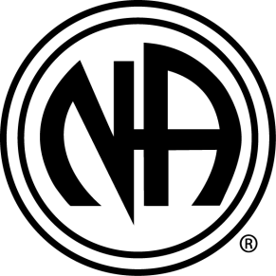
Steps To Freedom One Year Anniversary Party!
Please join us to help celebrate our one year anniversary! It will be held directly after the regular meeting on Friday, December 21st 2018.
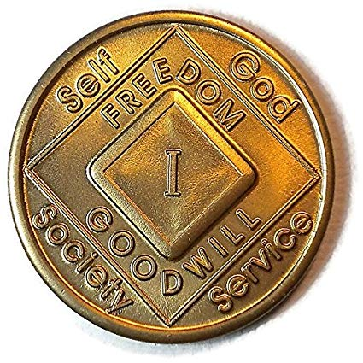
Time: 7:30pm – 8:30pm
Day: Friday, December 21st 2018
Place: The Fellowship Foundation Recovery Community Center
5400 W Atlantic Blvd. Margate, FL 33063
Format: 12 Step Rotating Format
*NA is not affiliated with The Fellowship Foundation Recovery Community Center

